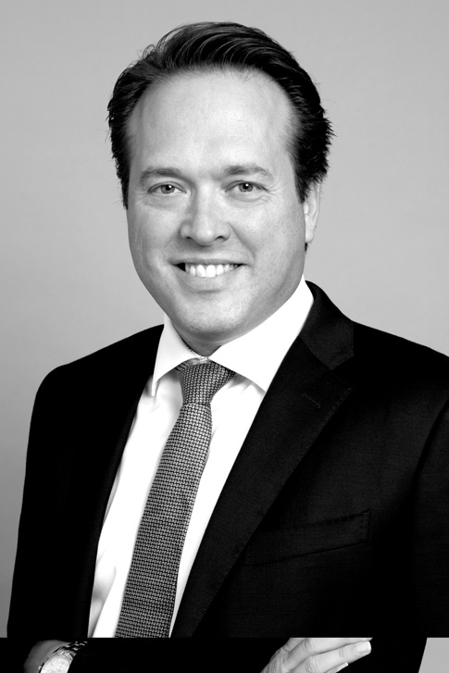 | David Aversten  Stockholm | Partner / Advokat  Mobiltelefon: +46 709 25 25 19  E-post: david.aversten@delphi.se  Språk: engelska, franska

Om
David Aversten är specialiserad på företagsförvärv och private equity-transaktioner. David företräder löpande såväl svenska som internationella private equity-fonder och deras portföljbolag, som svenska och internationella industriella klienter. David har omfattande erfarenhet av gränsöverskridande transaktioner inom ett stort spektrum av branscher, i synnerhet telekom-, media- och teknologibranschen. Intressanta uppdrag: • Veolia Nordics avyttring av Veolia Recycling och Industrial Cleaning • Veolia Nordics avyttring av Technical Management • Veolia Nordics avyttring av Utility Solutions • Veolia Water Technologies avyttring av VA-Ingenjörerna • Verdanes portföljbolag Desenios förvärv av Poster Store • EQT:s portföljbolag Candidator DGC:s förvärv av iSMoTec • Verdane Capitals försäljning och co-investment i EasyPark • Försäljning av Digpro AB till Litornia • The Carlyle Groups försäljning av BTI Studios till Altor Equity Partners • Veolia Nordics förvärv av Hans Andersson Recycling Group • Veolia Swedens förvärv av CRVR ETT AB (nu Veolia Industrial Services Sweden) från Corvara • EQT Ventures investeringar i Small Giant Games, Peltarion, Watty, Unomaly, Wolt, Verto och Min Doktor • Com Hems förvärv av Boxer

Kompetensområden
Företagsöverlåtelser, Private equity / Venture capital

Utbildning
Jur.kand., Stockholms universitet 1998Université de droit, d´economies d´Aix-Marseille, France 1996–1997
Erfarenhet
Partner, Advokatfirman Delphi 2007–Advokatfirman Vinge 2000–2007Tingstjänstgöring 1999–2000Advokatfirman Vinge 1998–1999
Rankingar
• Recommended, Private Equity, Band 4, Chambers Europe 2024• Recommended, Corporate/M&A, Band 3, Chambers Europe 2024• Recommended, Corporate/M&A, Band 3, Chambers Global 2024• Recommended, Practice area: Foreign Investment Review, M&A and Governance, Who’s Who Legal 2024• Highly regarded, M&A, IFLR 1000, 2023• Recommended, Private Equity, Band 2, Chambers Europe 2023• Recommended, Corporate/M&A, Band 2, Chambers Europe 2023• Recommended, Corporate/M&A, Band 2, Chambers Global 2023• National Leader, M&A and Governance, Who’s Who Legal 2023• Global Leader, Foreign Investment Review, Who’s Who Legal 2022• Highly regarded, M&A, IFLR 1000, 2022• Recommended, Corporate/M&A, Eminent Practitioners, Chambers Europe 2022• Recommended, Private Equity, Eminent Practitioners, Chambers Europe 2022• Recommended, Corporate/M&A, Eminent Practitioners, Chambers Global 2022• Global Leader, Foreign Investment Review, Who’s Who Legal 2021• National Leader, M&A and Governance, Who’s Who Legal 2021• Recommended, Corporate/M&A, Eminent Practitioners, Chambers Global 2021:• “very good at complex situations that don’t arise normally.”• Recommended, Corporate/M&A, Eminent Practitioners, Chambers Europe 2021• Recommended, Private Equity, Eminent Practitioners, Chambers Europe 2021• Highly regarded, M&A, IFLR 1000, 2021• Global Leader, Practice Area: M&A and Governance, Category: Foreign Investment Review, Who’s Who Legal 2020• Recommended, Commercial, Corporate and M&A, tier 3, Legal 500, 2020• Recommended, Corporate/M&A, Eminent Practitioners, Chambers Europe 2020• “According to clients, David Aversten is ‘pragmatic and efficient as well as client-oriented.’ His practice covers M&A and private equity mandates, including venture capital deals.”• Recommended, Private Equity, Eminent Practitioners, Chambers Europe 2020• Recommended – National Leader, Practice Area: M&A & Governance 2020, Who’s Who Legal 2020• Recommended, Corporate/M&A, Eminent Practitioners, Chambers Global 2020• Highly regarded, M&A, IFLR 1000, 2020• “Very competent and experienced. Came with highly relevant thoughts and feedback. Very accessible.”• Highly regarded, Private Equity, IFLR 1000, 2020• Global Leader, Practice Area: M&A and Governance, Category: Foreign Investment Review, Who’s Who Legal 2019• Highly regarded, M&A, IFLR 1000, 2019• Highly regarded, Private Equity, IFLR 1000, 2019• Recommended, Commercial, Corporate and M&A, tier 3, Legal 500, 2019• Recommended, Corporate/M&A, band 2, Chambers Europe 2019:• “David Aversten advises both private equity funds and corporate clients on acquisitions and divestments. Clients appreciate his responsiveness and availability, describing him as “always on call and willing to help out.” He represented Veolia Nordic in its acquisition of Hans Andersson Recycling Group.”• Recommended, Private Equity, band 3, Chambers Europe 2019:• “David Aversten advises on cross-border and domestic private equity deals, with particular experience in venture capital transactions. Aversten attracts attention for his “very commercial and very straightforward” approach.”• Recommended, Corporate/M&A, band 2, Chambers Global, 2019:• “David Aversten advises both private equity funds and corporate clients on acquisitions and divestments. Clients appreciate his responsiveness and availability, describing him as “always on call and willing to help out.” He represented Veolia Nordic in its acquisition of Hans Andersson Recycling Group.”• Recommended, M&A and Governance, Who’s Who Legal, 2019• Recommended, Commercial, corporate and M&A, Legal 500, 2018• Highly regarded, M&A, IFLR 1000, 2018• Highly regarded, Private equity, IFLR 1000, 2018• Recommended, Corporate/M&A, band 2, Chambers Europe 2018• Recommended, Private Equity, band 3, Chambers Europe 2018• Recommended, Corporate/M&A, band 2, Chambers Global 2018• Recommended, Commercial, corporate and M&A, tier 2, Legal 500, 2017• Recommended, Corporate/M&A, band 2, Chambers Global 2017• Leading Lawyer, M&A, IFLR 1000, 2017• Leading Lawyer, Private equity, IFLR 1000, 2017• Recommended, Private Equity, band 3, Chambers Europe 2017• Recommended, Corporate/M&A, band 2, Chambers Europe, 2016• Recommended, Energy, tier 3, Legal 500, 2014• Highly recommended, Corporate and M&A, Legal Experts EMEA, 2013• Recommended, Corporate and commercial, tier 2, Legal 500, 2013• Recommended, Private equity: buyouts, PLC Which Lawyer, 2012• Recommended, Real estate, Legal 500, 2012• Recommended, Corporate/M&A, PLC Which Lawyer, 2012• Recommended, Private equity: buyouts, PLC Which Lawyer, 2012
Publikationer
• Svensk Private Equity — en översikt, artikel om “Transactions”, publicerad i Getting the Deal Through, 2014• Svensk Private Equity — en översikt, artikel om “Transactions”, publicerad i Getting the Deal Through, 2013• Svensk Private Equity — en översikt, artikel om “Transactions”, publicerad i Getting the Deal Through, 2012• Private Equity, Transactions, Sweden. Reproduced with permission from Law Business Research. Artikeln publicerades ursprungligen i Getting the Deal Through – Private Equity 2011, (published in March 2011; contributing editor: Casey Cogut of Simpson Thacher & Bartlett). För ytterligare information, se www.GettingTheDealThrough.com• Controlling purchase prices: the locked box mechanism, ILO Newsletter, Corporate Finance/M&A – Sweden, November 2010• Earn-out Models for Mergers and Acquisitions, ILO Newsletter, January 2010• Svensk Private Equity — en översikt, artikel om “Transactions”, publicerad i Getting the Deal Through, mars 2010• Svensk Private Equity — en översikt, artikel om “Transactions”, publicerad i Getting the Deal Through, februari 2009 Earn-out Models for Mergers and Acquisitions
Medlemskap
Sveriges advokatsamfundLedamot av svenska ICC:s (International Chamber of Commerce) referensgrupp handelsrättInternational Bar Association (IBA)DataföreningenADBJ – Svenska föreningen för IT och Juridik

